What to Bring to Habitat for Humanity

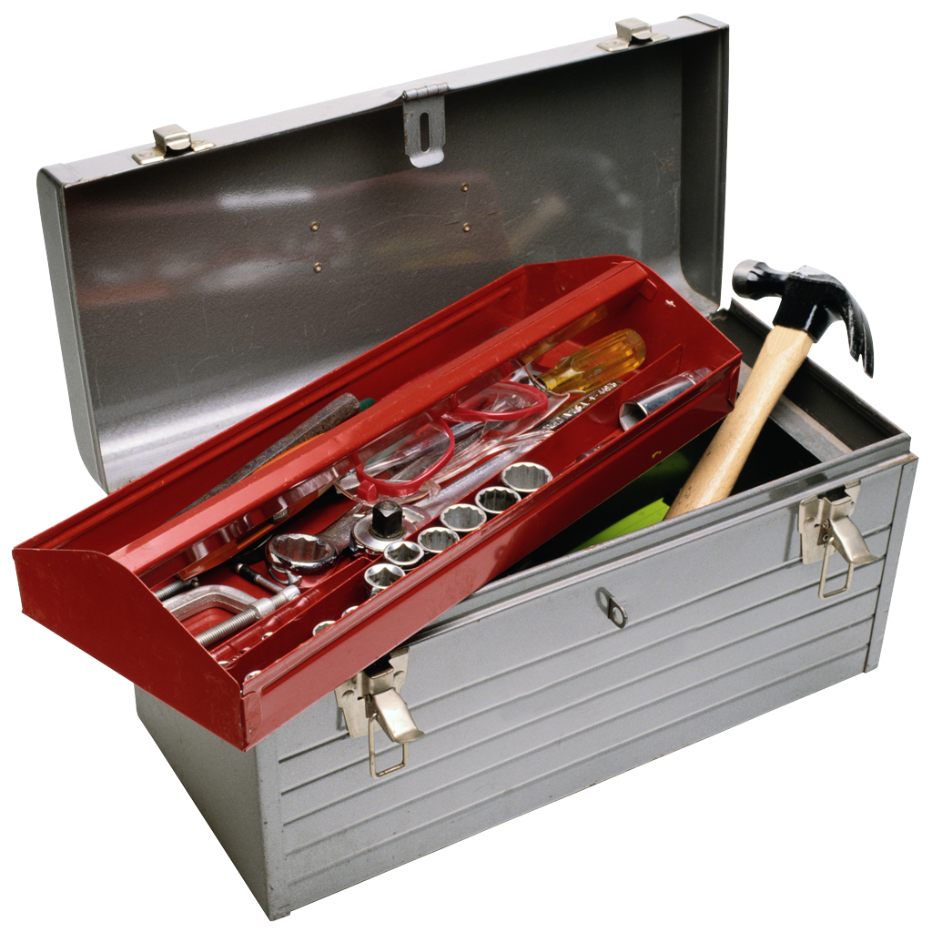
- Worksite materials:
  - Work gloves (usually provided for onsite, but just in case)
  - Hard soled shoes
  - Wet wipes
  - Protective glasses (usually provided for onsite, but just in case)
  - Sunscreen
- Sleeping bag and pillow
- Mat or air mattress
- Towel (shower and beach… or just share)
- Shower shoes and smaller bag to carry change of clothes
  - We shower off-site so you need to pack toiletries, towel, and change of clothes every day
- Old grocery bags to put smelly clothes in
- Toiletries
  - Shampoo and soap
  - Toothbrush and toothpaste
  - Deodorant, please!
- Casual clothes and work clothes (wear stuff to the site that you can get dirty)
- Socks and underwear, please!
- Camera, phone, and chargers
- Meal money for the returning Saturday trip/ ice cream runs
- Board games, sports equipment, cards, etc.
- BIBLE, journal, rosary, other prayer materials
- Snacks to share! Remember, we got a whole week… (No nuts please!)
- Hat or bandana
- Water Bottle
- Bathing suit for the beach day
- Desire to work & pray hard!

