What to Bring to Habitat for Humanity

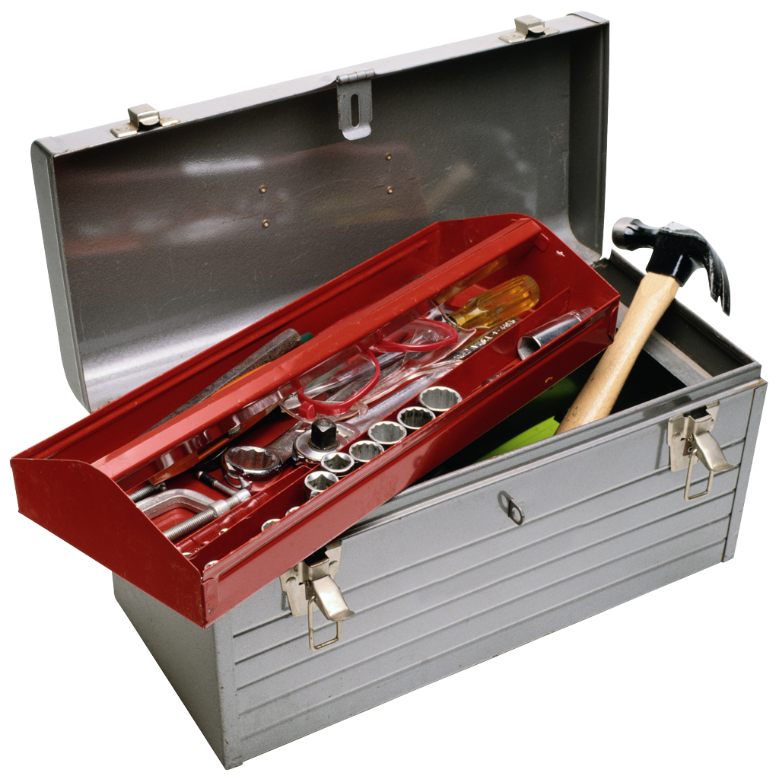
- Worksite materials:
  - Work gloves (usually provided for onsite, but just in case)
  - Hard soled shoes
  - Wet wipes
  - Protective glasses (usually provided for onsite, but just in case)
  - Sunscreen
- Sleeping bag and pillow
- Mask
- Hand sanitizer
- Mat or air mattress (optional)
- Toiletries
  - Shampoo and soap
  - Toothbrush and toothpaste
  - Deodorant, please!
- Casual clothes and work clothes (wear stuff to the site that you can get dirty)
- Socks and underwear, please!
- Camera, phone, and chargers
- Meal money for the road or ice cream runs
- Board games, sports equipment, cards, etc.
- BIBLE, journal, rosary, other prayer materials
- Individually packaged snacks to share! (No nuts please!)
- Hat or bandana
- Water Bottle
- Bathing suit for the beach day
- Desire to work & pray hard!

